USER REQUIREMENTS

The Bidder should provide the following in the specified order in Section 4 of the proposal/bid document.

Provide detail information of the proposed solution as per document enclosed. Please note that marking should be carried out in the following manner; The Remarks column should be used to explain or provide detail information.

DESCRIPTION | REMARKS
Rating - 5 | If the User requirement is met 100% as defined in the RFP without any work around method.
Rating - 4 | If the User requirement is met 75% as defined in the RFP without any work around method. Define the number of hours required for the modification and cost in US$ in the Remarks column, in order to provide 100% functionality as defined.
Rating - 3 | If the User requirement is met 50% as defined in the RFP without any work around method. Define the number of hours required for the modification and cost in US$ in the Remarks column, in order to provide 100% functionality as defined.
Rating - 2 | If the User requirement is met 25% as defined in the RFP without any work around method. Define the number of hours required for the modification and cost in US$ in the Remarks column, in order to provide 100% functionality as defined.
Rating - 1 | If the User requirement is met as a Work around method defined in the RFP. Define the number of hours required for the modification and cost in US$ in the Remarks column, in order to provide 100% functionality as defined.
Rating - 0 | If the User requirement is not met as a defined in the RFP and modifications are required. Define the number of hours required for the modification and costs in US$ in the Remarks column.

The NBL rating is as follows:
1 = critical; 2 = essential; 3 = nice to have

CALL DEPOSITS
Ref | User Requirements of Call Deposits | NBL Priority | Bidder’s Rating | Bidder’s Remarks
 | Facility to maintain basic customer information.  Maintain operating instructions. | 1 | 4 | Supported by T24 through Customer Module. Operating instructions may require local enhancement. This was discussed during the POC.
 | Lock as a under lien deposit | 1 | 5 | Handled by T24 Collateral module.
 | Maintain Withholding tax recovered to obtain a statement at any particular date | 1 | 5 | Supported by T24
 | Identify the operative or inoperative status of the call deposit. | 1 | 5 | Supported by T24
 | Transfer of dormant category and lock the account if the account is inoperative for a specified period | 1 | 5 | Dormant account processing is a standard T24 function and is user-defined.  T24 provide parameter table POSTING.RESTRICT to define specific transactions which prohibited for an account.  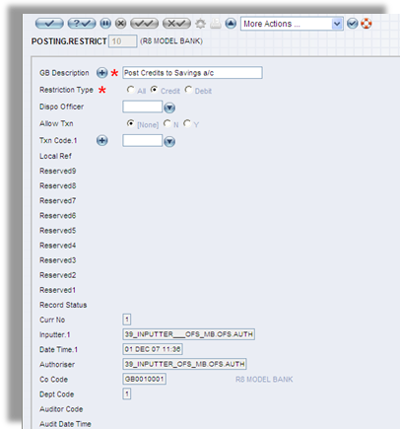  Figure 1. POSTING.RESTRICT
 | Identification of Currency type | 1 | 5 | T24 is a multi-currency system by design and supports multiple currencies in terms of transactions, accounting. All currencies to be used are defined in the Currency table with currency code (usually according to ISO standard), number of decimal places, quotation rules, delivery days…  T24 supports multiple currencies and manage foreign currencies as well as local currency at all the business areas indicated. Transactions can be done for any defined currencies. An example of multi-currency facility is that a loan facility (limit) can be defined in one currency while the loan contract can be input in another currency and then drawdown can again be in a third currency, if necessary.  In addition, T24 supports multi-currency payments, disbursement and settlements. Payment/ settlement messages will be generated in the appropriate currency as specified in the transaction.
 | Interest should be calculated at the maturity / at the upliftment | 1 | 5
 | Revaluation of currency rates for FC accounts. | 1 | 5 | The revaluation in T24 is done on a daily basis during COB process.
 | Maintenance of Currency table | 1 | 5 | T24 maintains Currency table, which can be linked to information feed system. As such, the currency exchange rates can be updated on an online real-time basis. The Currency table contains all details of each individual Currency, for example Currency Name, Number of Decimal places together with other information such as the Buy and Sell rates. The currency tables are also utilised for storage of information pertaining to precious metals such as gold, sliver…
 | Currency Revaluation report | 1 | 5 | T24 provides a centralised revaluation parameter table whereby the Bank can design its currency revaluation policy. At the end of the each close of business day and prior to report production, all non-contingent foreign currency records will then be revalued.  The revaluation involves revaluing each currency record by type. The total new local equivalent from all currency records is checked against the local equivalent from the Asset and Liability Consolidate file is adjusted by that amount. The adjustment raises a revenue accounting entry for the amount of each revaluation and will be posted in accordance to the policy set-up in the Revaluation Parameter table.
 | Generation of G/L entries automatically through the system. | 1 | 5 | This is Supported by T24. T24 generally provides for automatic accounting treatment based on the predefined rules. Accounting entries are generated automatically upon successful input of a transaction. Where transactions are inputted simultaneously, accounting entries are also generated in parallel for each simultaneous transaction.  Temenos T24 has built in functionality to ensure that the integrity of the accounting entries is maintained. In some instances where the accounting entries are accepted standards and any breach will go against the accepted principles of accounting, T24 ensures that the proper accounts are created automatically.

